C A T Á L O G O

FRAICHE

D A M A
PARA ELLA

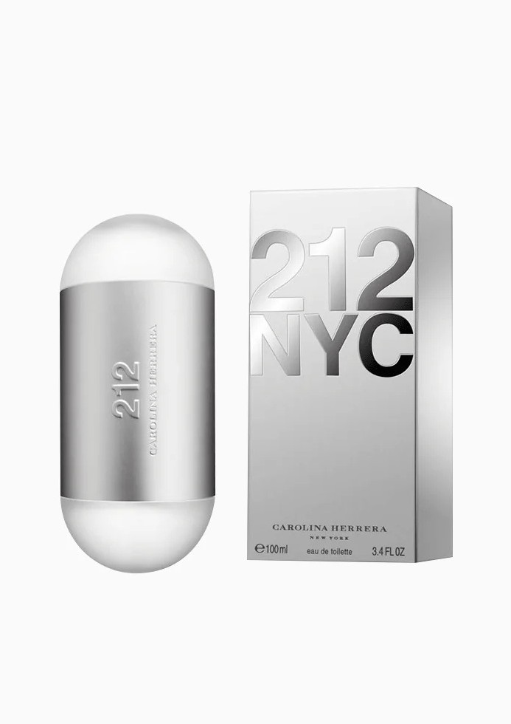
212
CAROLINA HERRERA

212 VIP
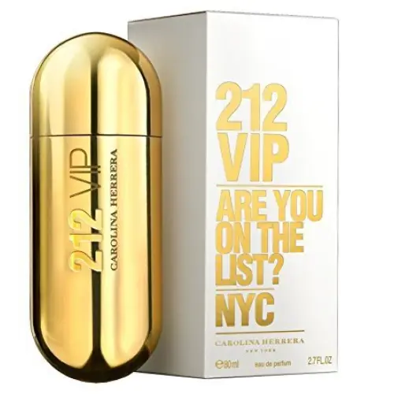
CAROLINA HERRERA

212 VIP ROSE
CAROLINA HERRERA

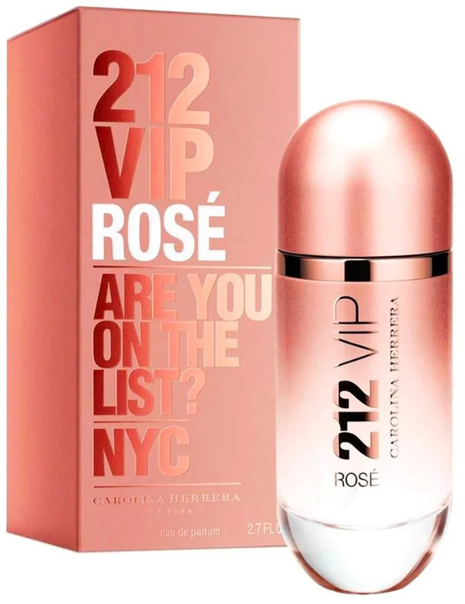

360
PERRY ELIS

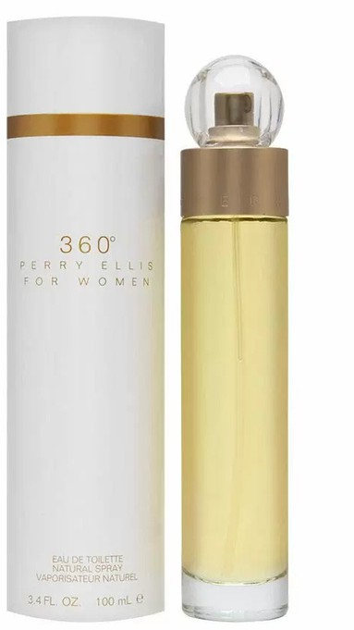

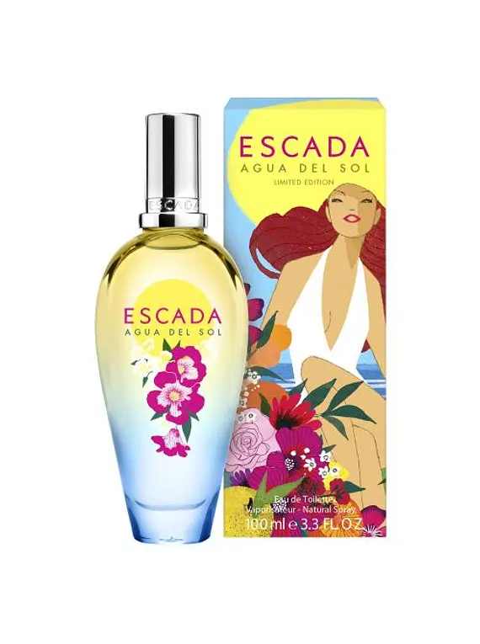
AGUA DEL SOL
ESCADA

AMOR AMOR
CACHAREL
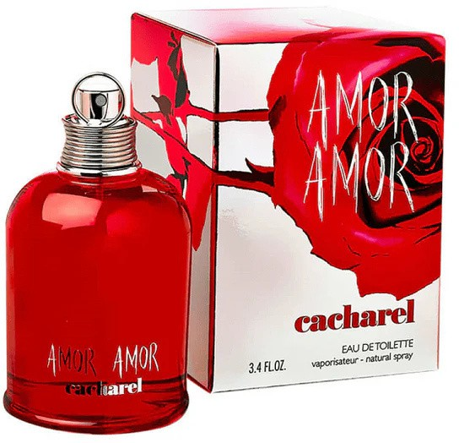

ANGEL
THIERRY MUGLER

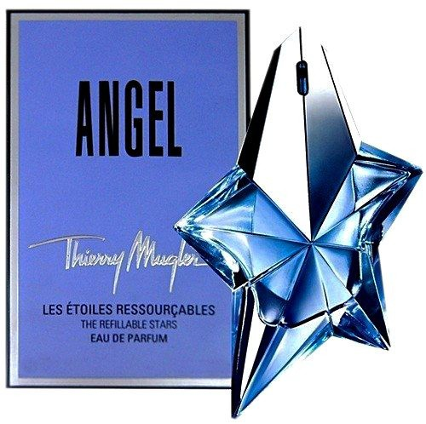

BOMSHELL
VICTORIA’S SECRET

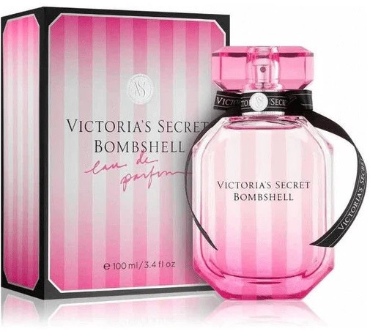

BRIGHT CRISTAL
VERSACE

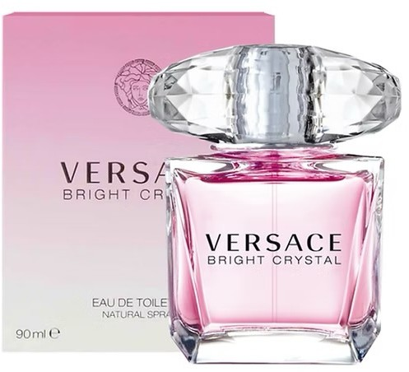

BURBERRY BOREAL
BURBERRY

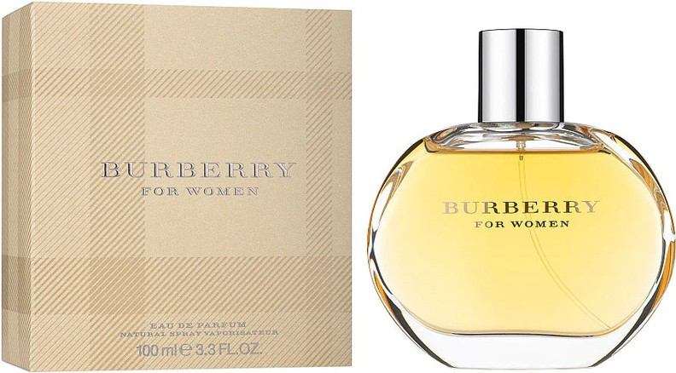

BURBERRY HER
BURBERRY

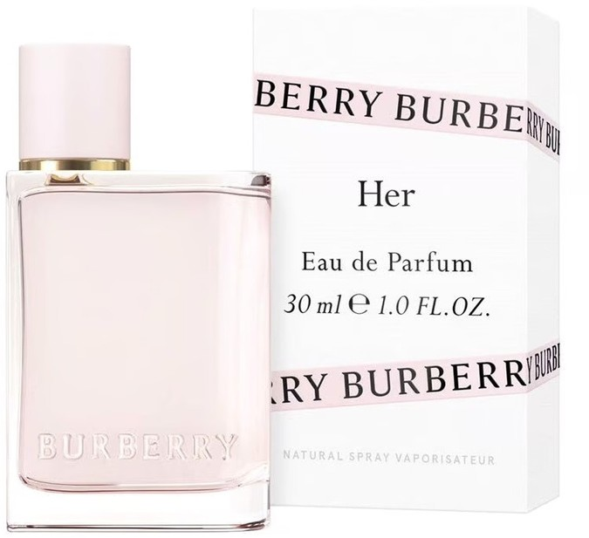

CAN CAN
PARIS HILTON

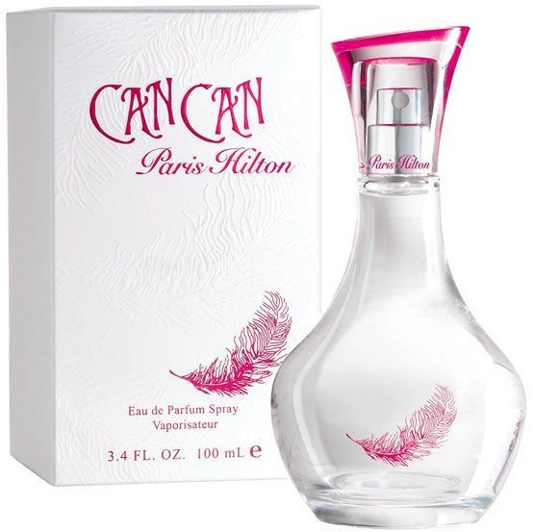

CAROLINA HERRERA
CAROLINA HERRERA

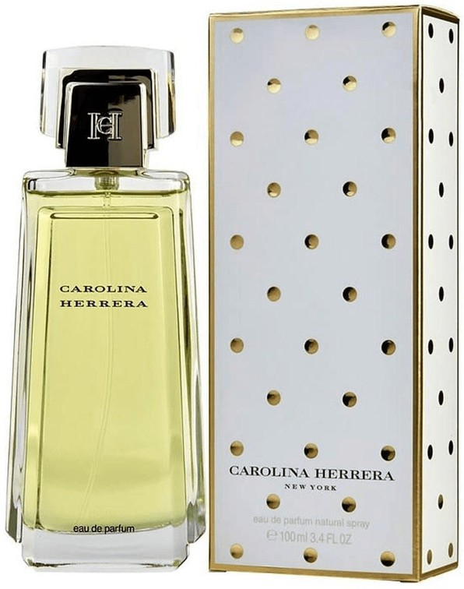

CH
CAROLINA HERRERA

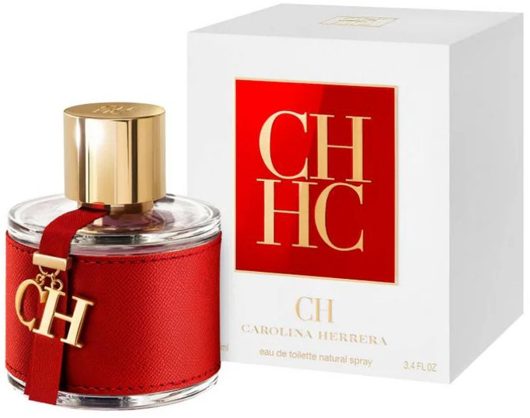

CHANCE
CHANEL

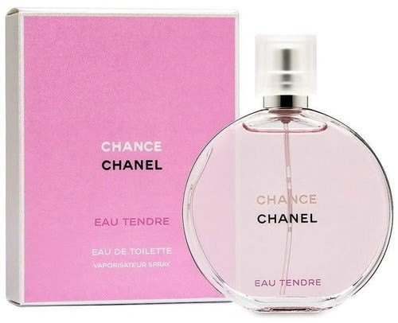

CHANEL 5
CHANEL

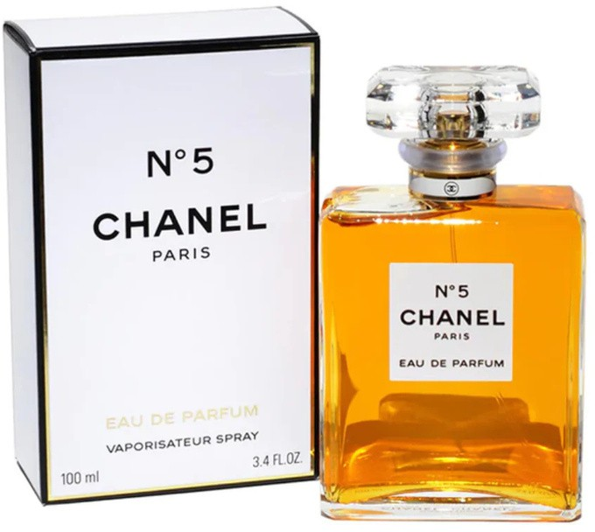

CK IN2U
CALVIN KLEIN

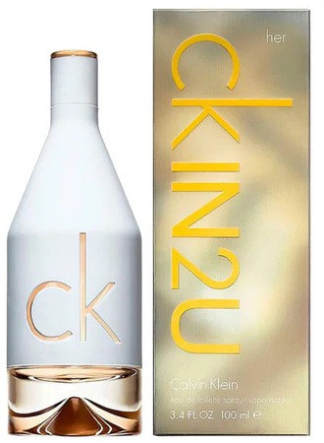

CLOUD
ARIANA GRANDE

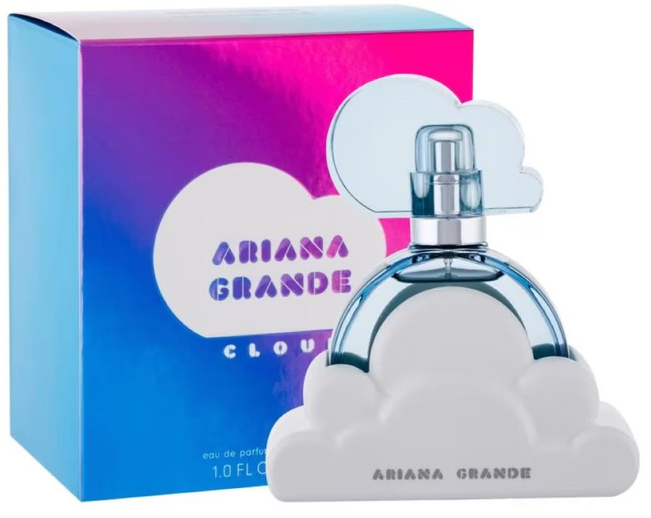

CLOUD PINK
ARIANA GRANDE

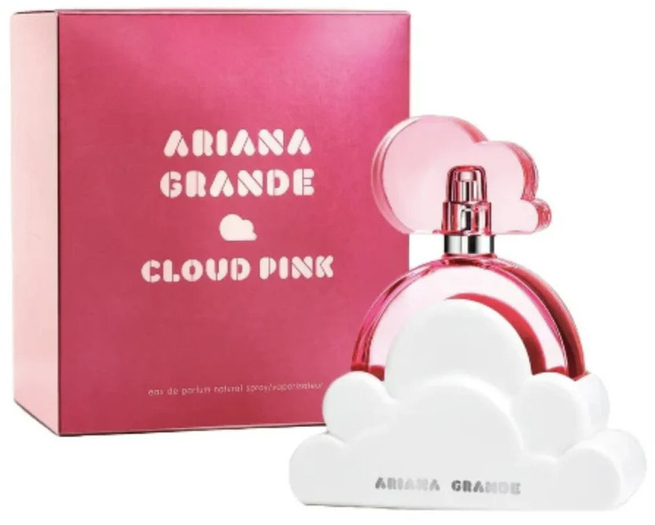

COCO CHANEL
CHANEL

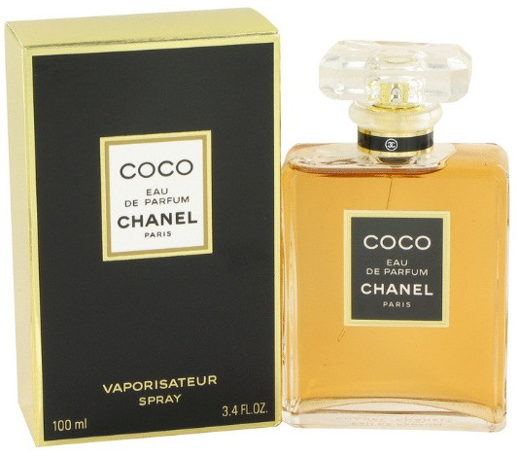

COCO MADEMOISELLE
CHANEL

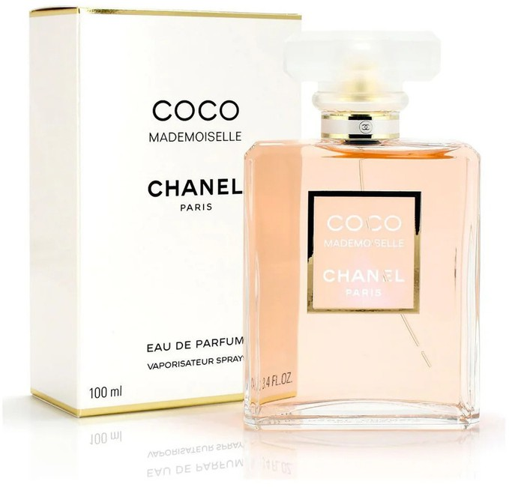

DAHAB KAJAL
KAJAL

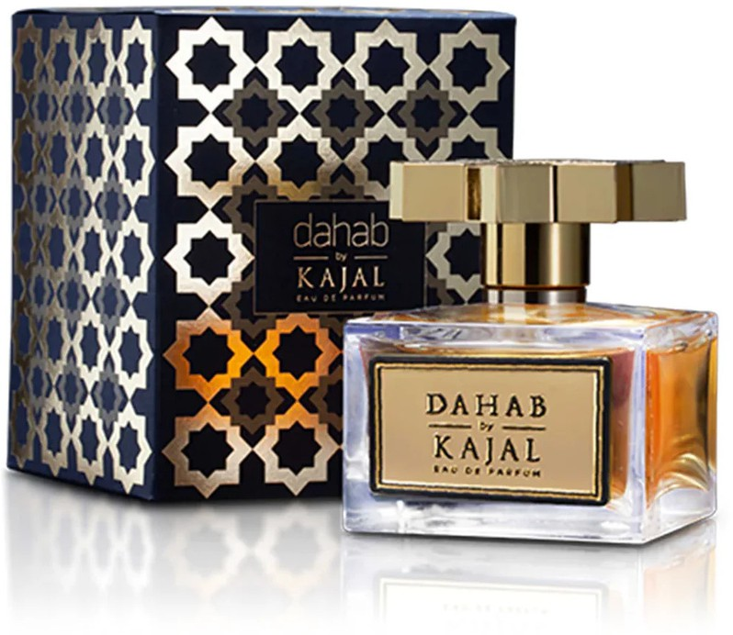

DELINA
MARLY DE PARFUMS

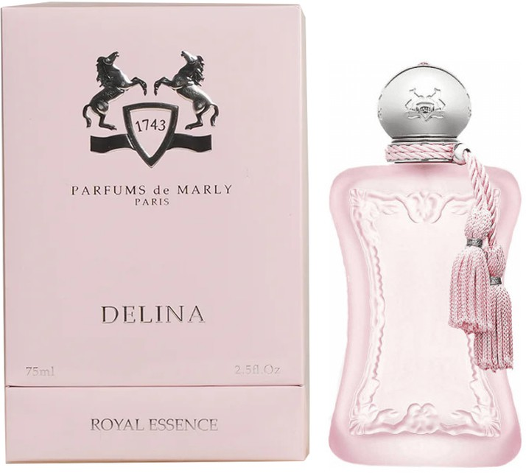

DYLAN PURPLE
VERSACE

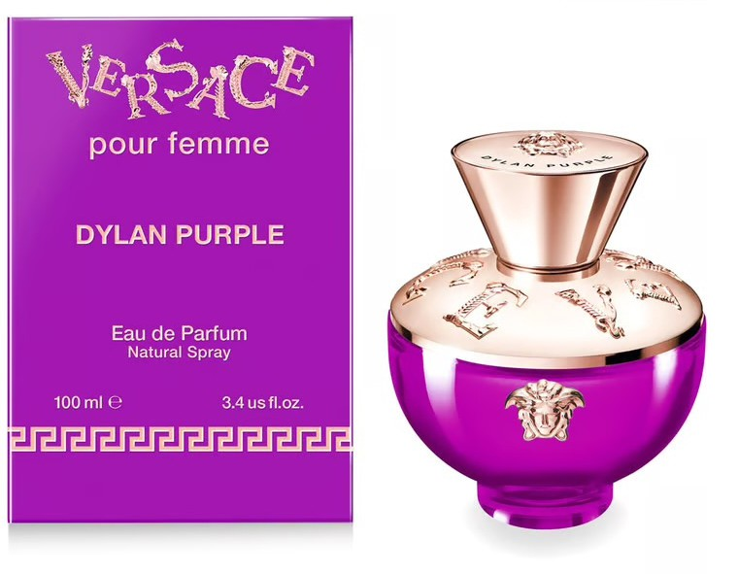

CHERRY IN AIR
ESCADA
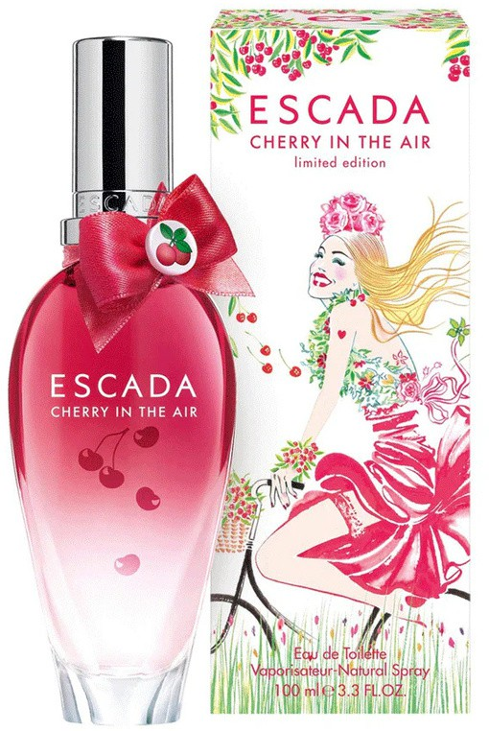

ETERNITY
CALVIN KLEIN

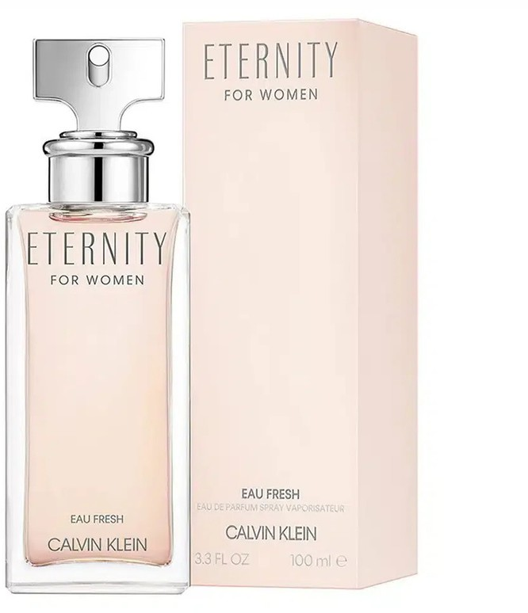

FANTASY
BRITNEY SPEARS

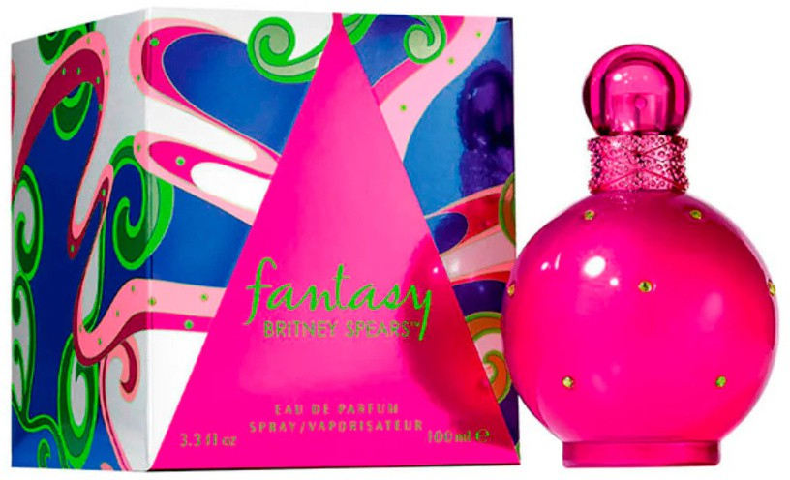

FLOWER RED
KENZO

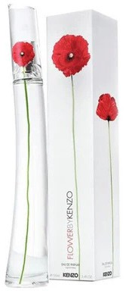

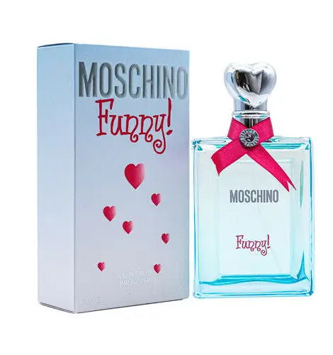
FUNNY
MOSCHINO

GOOD GIRL
CAROLINA HERRERA

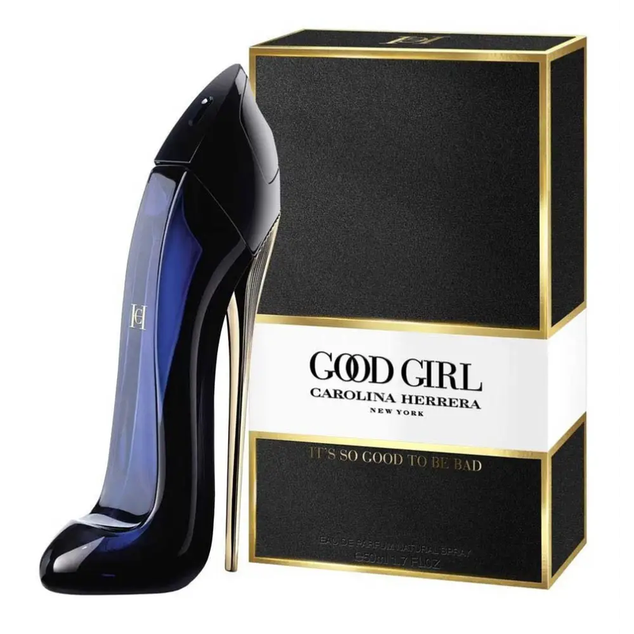

GUESS
GUESS

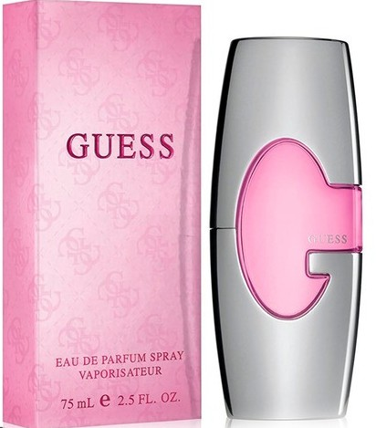

HALLOWEEN
JESUS DEL POZO

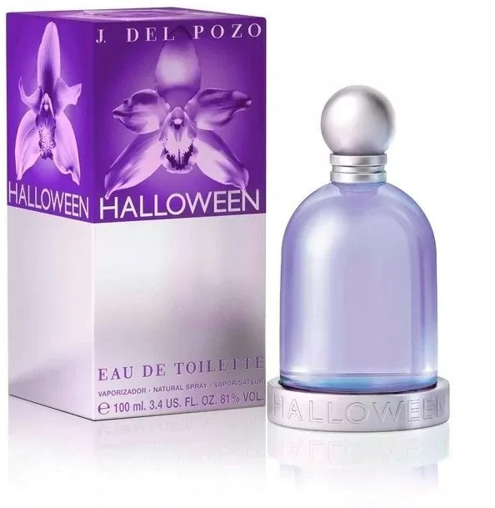

HEIRESS
PARIS HILTON
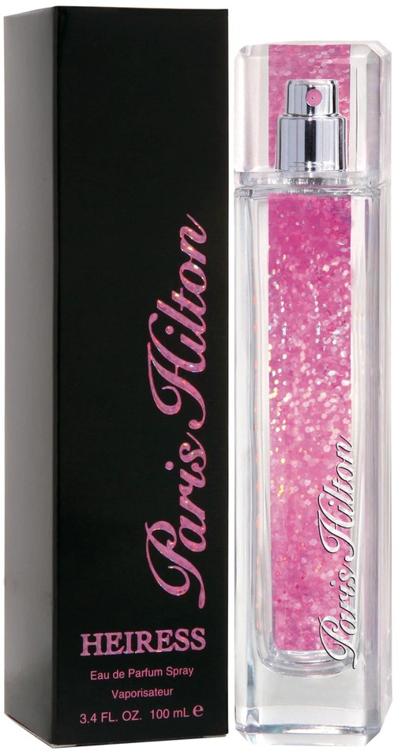

HOT HOT HOT
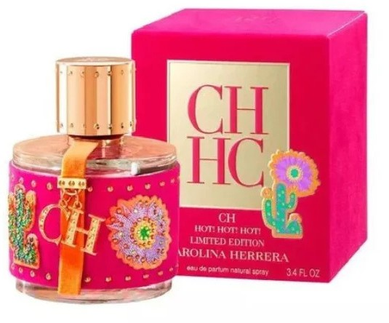
CAROLINA HERRERA

ILROSO
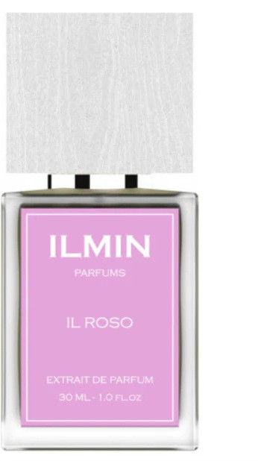
ILMIN

ISSEY MIYAKI
ISSEY MIYAKI

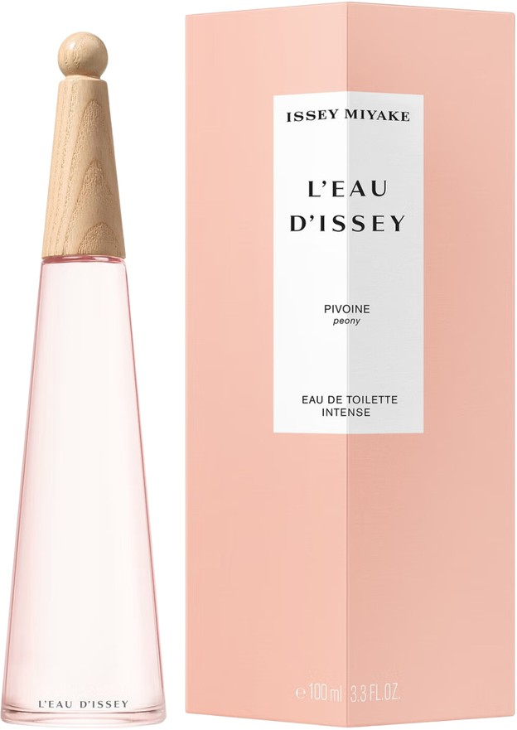

JADORE
CHRISTIAN DIOR
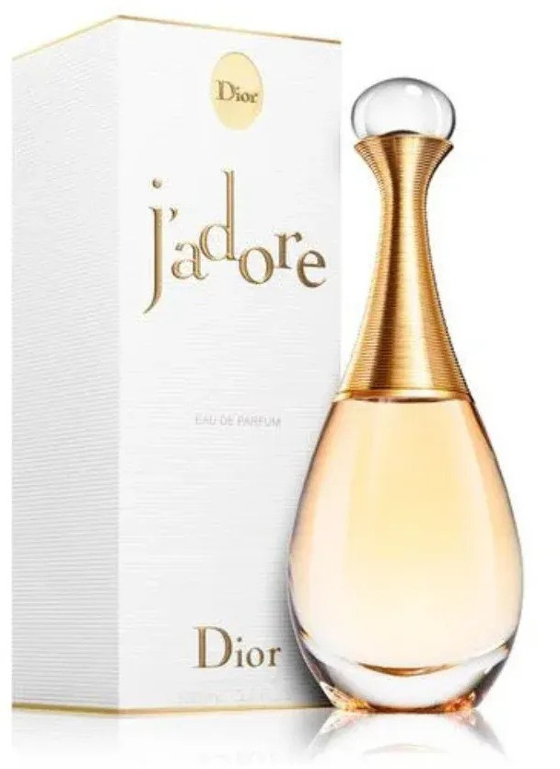

ORIENTICA VELVET GOLD
ORIENTICA

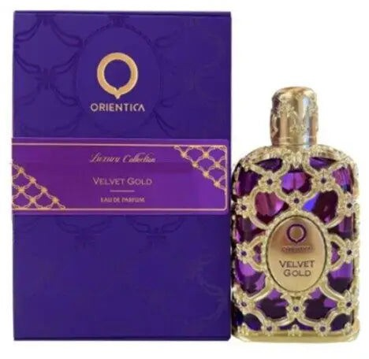

LA VIDA ES BELLA
LANCOME

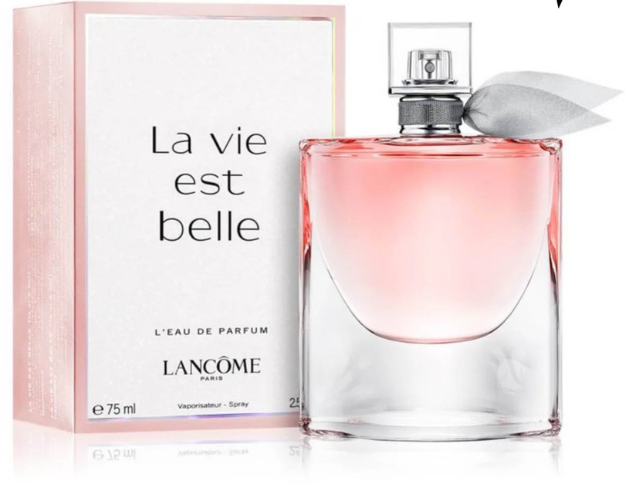

LACOSTE SPARKLING
LACOSTE

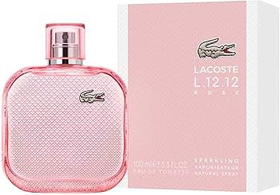

LADY MILLION
PACO RABANNE

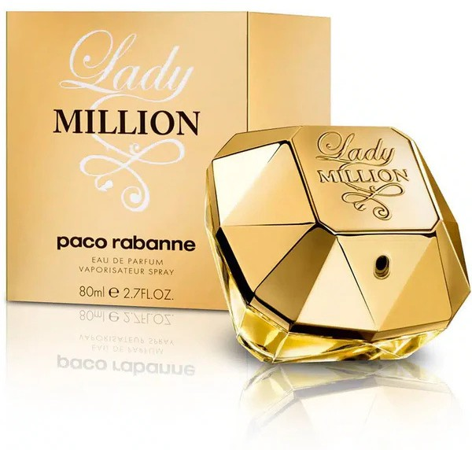

LIGHT BLUE
DOLCE s GABANNA

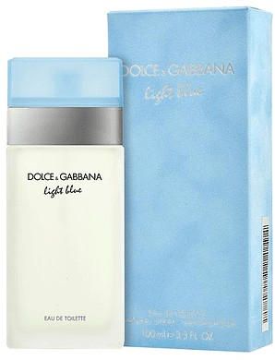

LOLITA LEMPIKA
LOLITA LEMPIKA

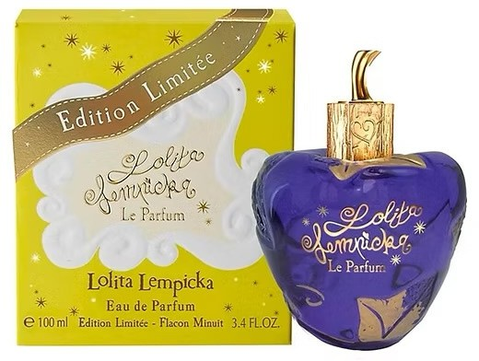

MEOW
KATY PERRY

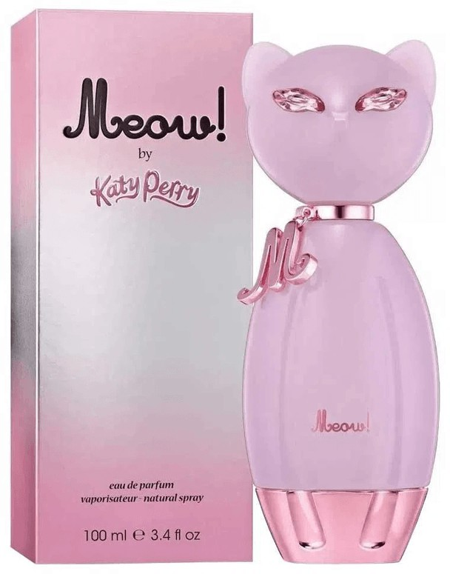

MOON SPARKLE
ESCADA

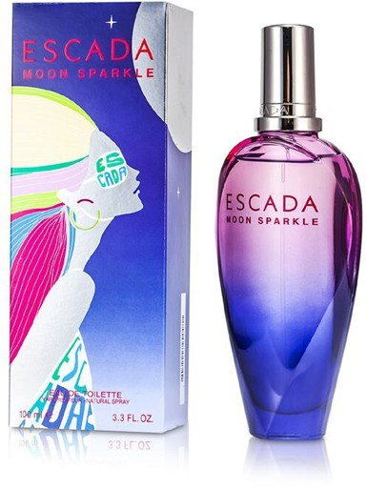

OLYMPEA
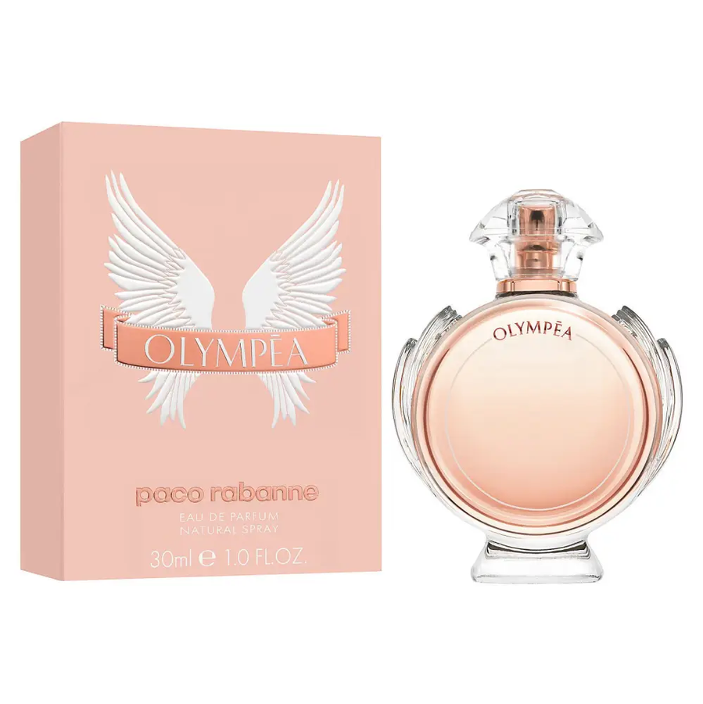
PACO RABANNE

OMNIA AMATISTA
BULGARI

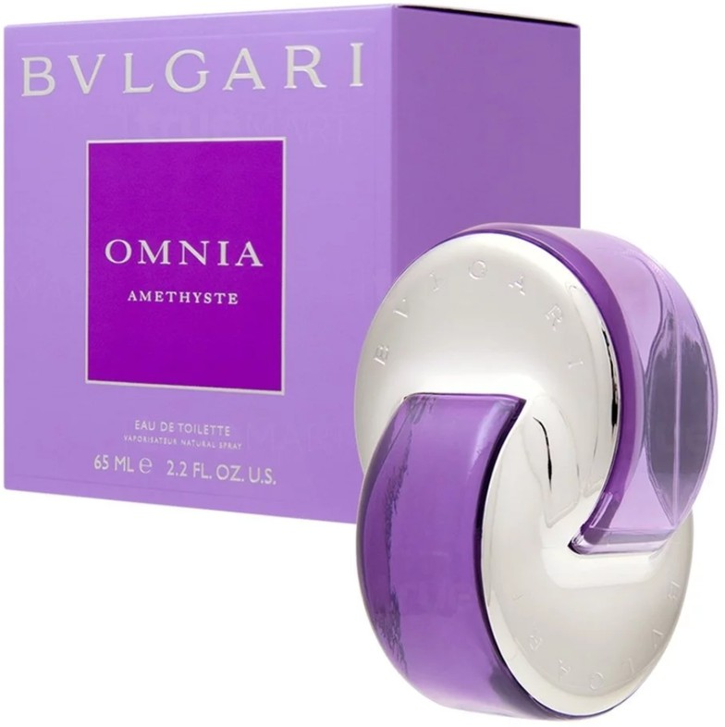

OMNIA CORAL
BULGARI

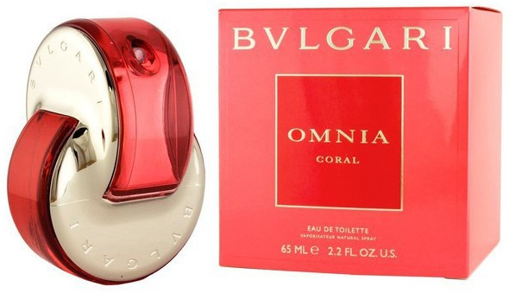

OMNIA CRISTAL
BULGARI

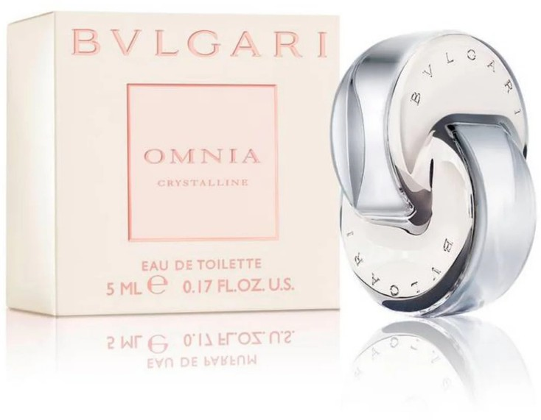

PARIS HILTON
PARIS HILTON

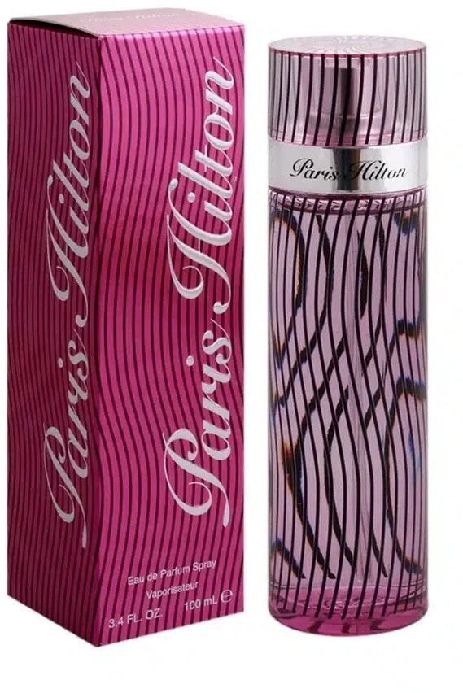

PASSPORT PARIS
PARIS HILTON

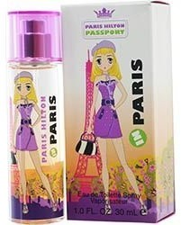

Q
DOLCE s GABANNA

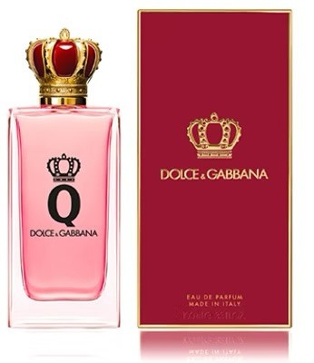

RALPH
RALPH LAURENT

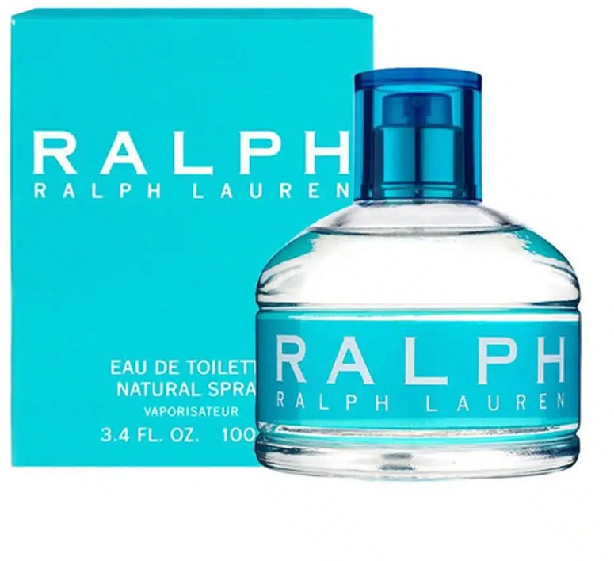

S BY SHAKIRA
SHAKIRA

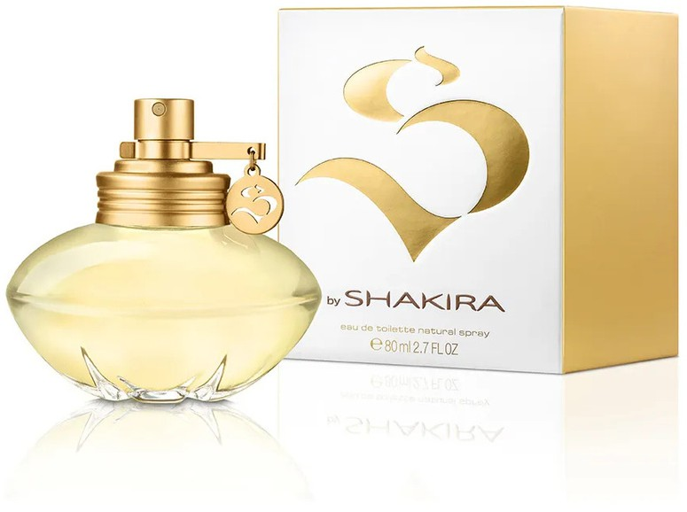

SELENA GOMEZ
SELENA GOMEZ

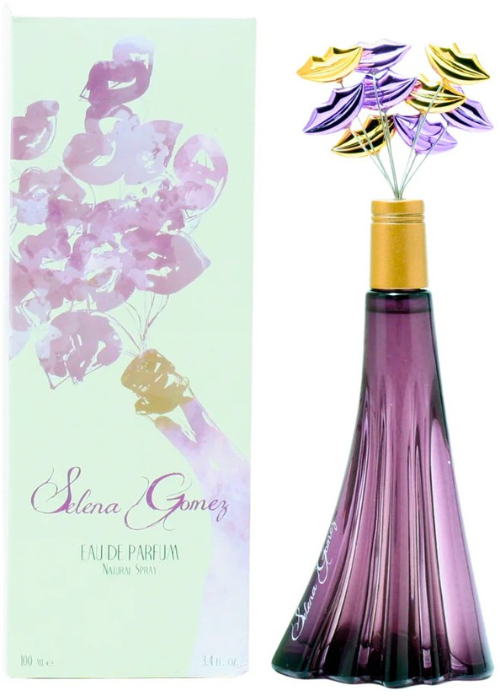

SORBETTO ROSSO
ESCADA

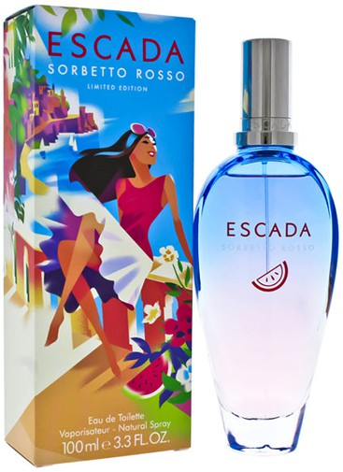

SWISS ARMY
SWISS ARMY

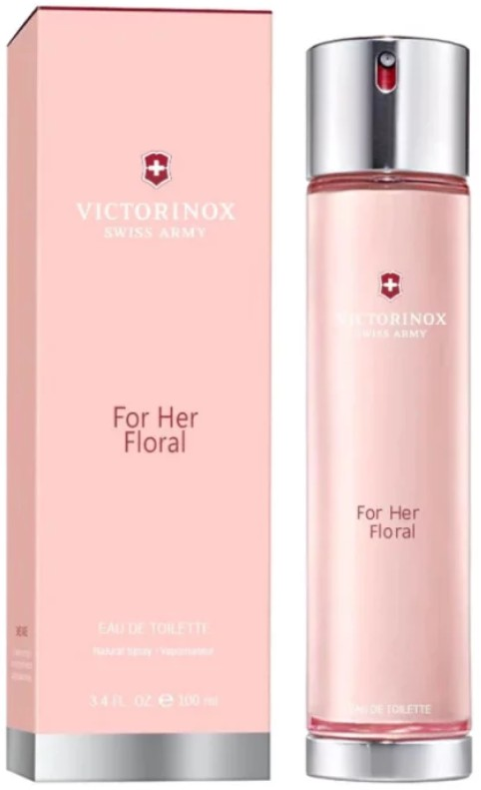

TAJ SUNSET
ESCADA

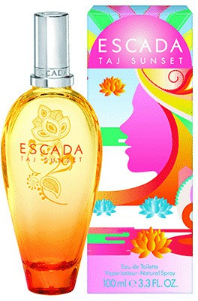

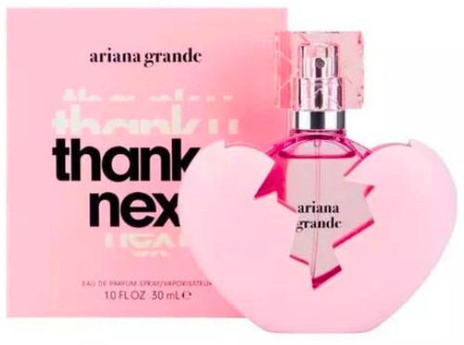
THANK U NEXT
ARIANA GRANDE

TOMMY GIRL
TOMMY HILFIGER

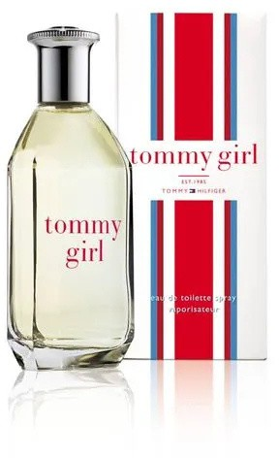

TOY 2
MOSCHINO

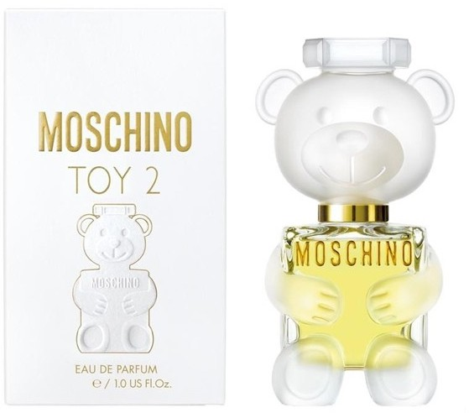

TOY 2 BUBBLE GUM
MOSCHINO

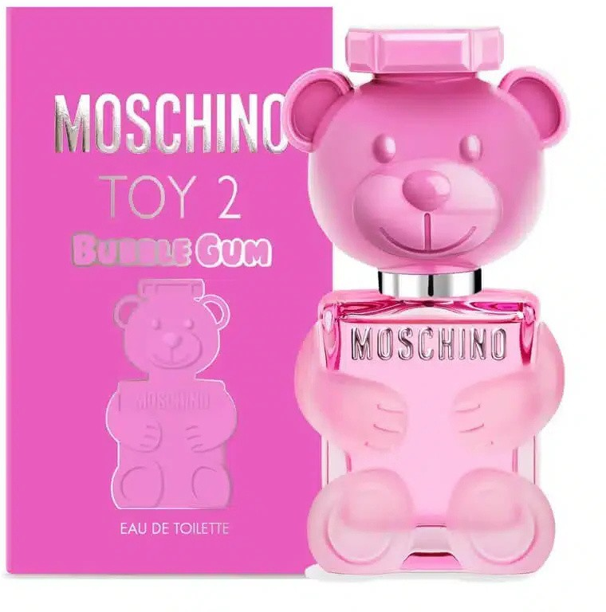

WITHE DIAMONDS
ELIZABETH TAYLOR

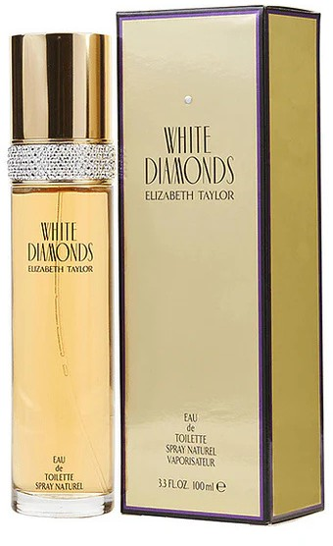

YARA
LATTAFA PERFUMS

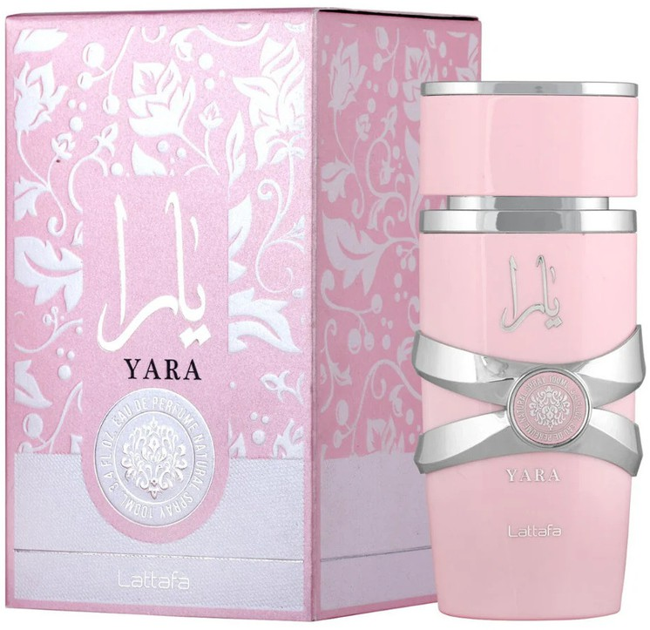

YARA CANDY
LATTAFA PERFUMS

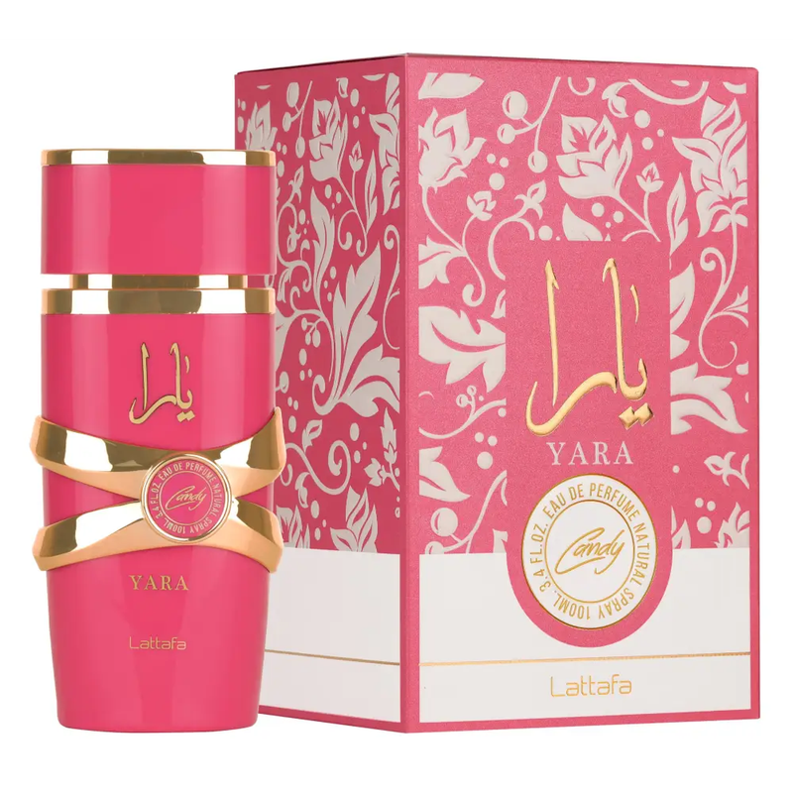

YARA TOUS
LATTAFA PERFUMS

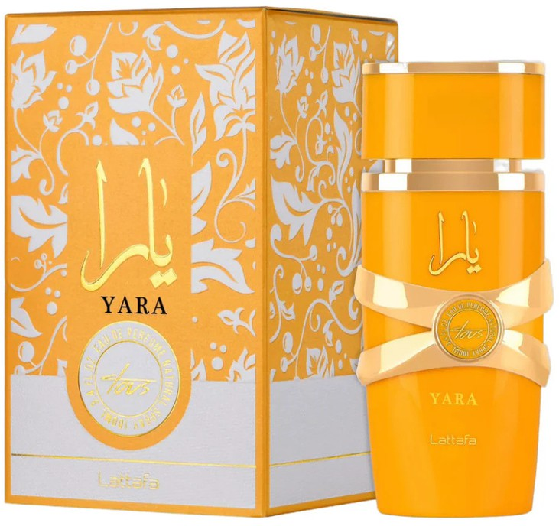

GOOD GIRL BLUSH
CAROLINA HERRERA

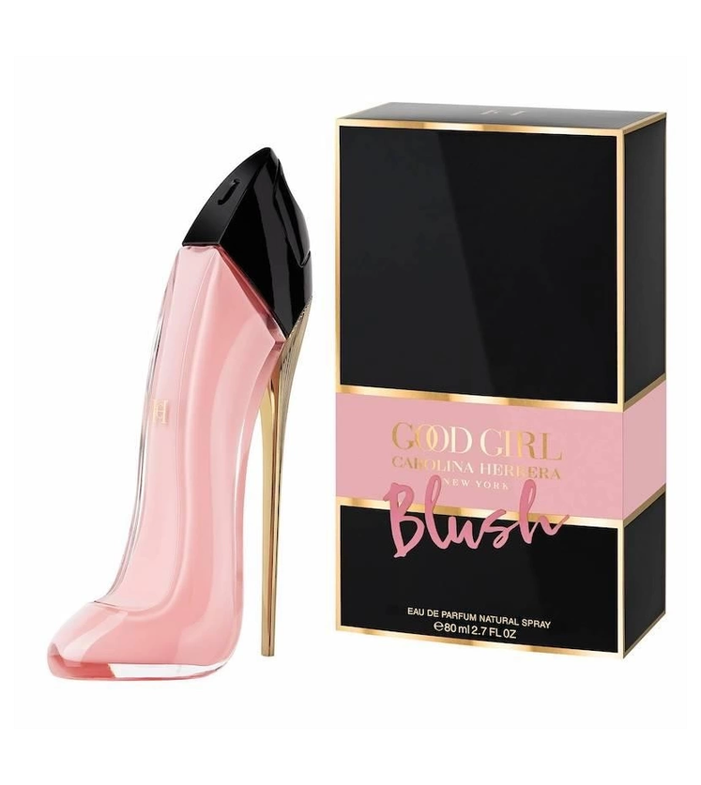

LA BOMBA
CAROLINA HERRERA

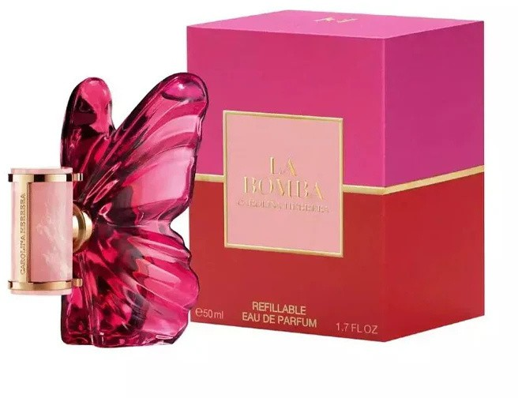

MAYAR
LATTAFA

MISS DIOR PARFUM
DIOR

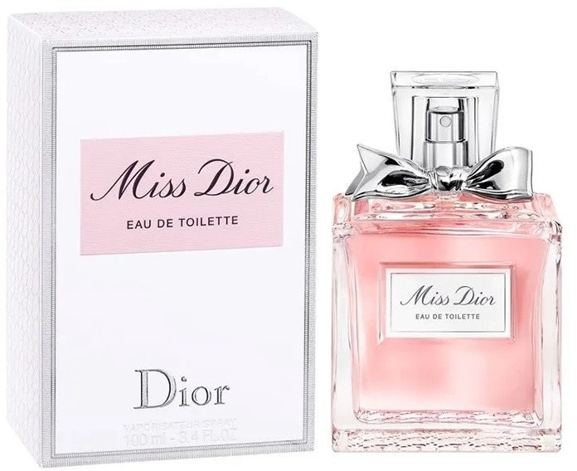

NOBLE BLUSH
LATTAFA

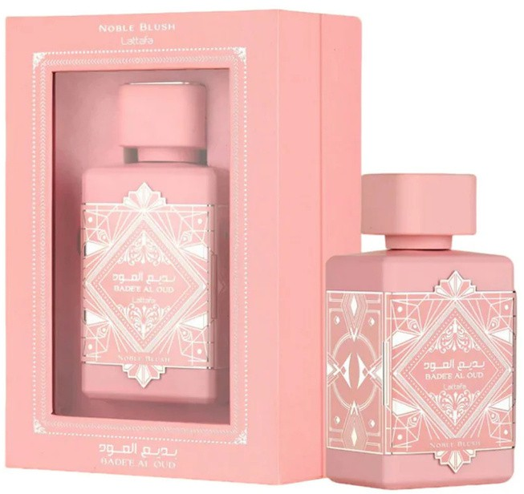

YUM MARSHMALOW
KAYALI

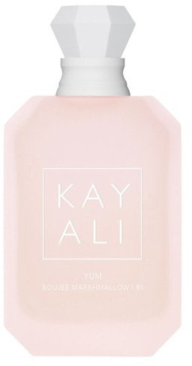

YUM YUM
ARMAF

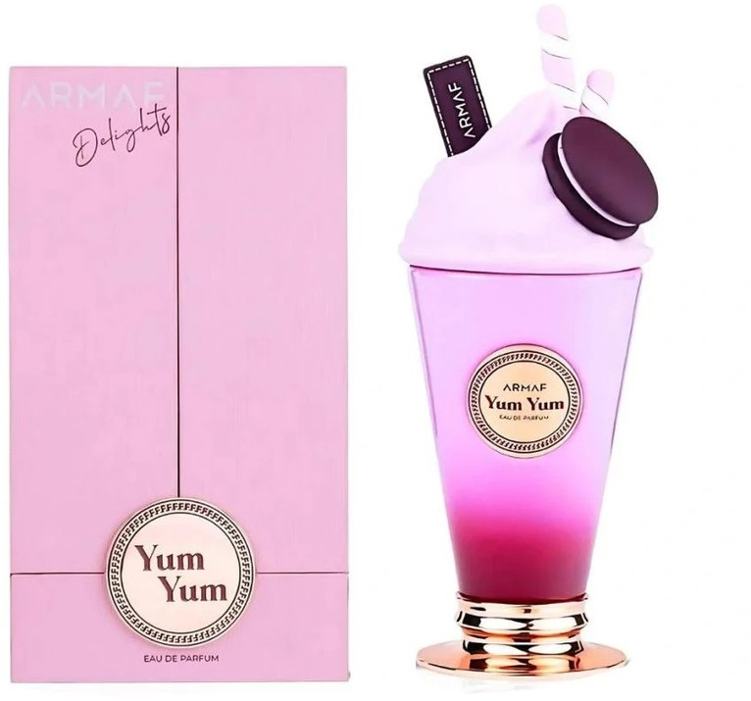

CHOCO OVERDOSE
LATTAFA

